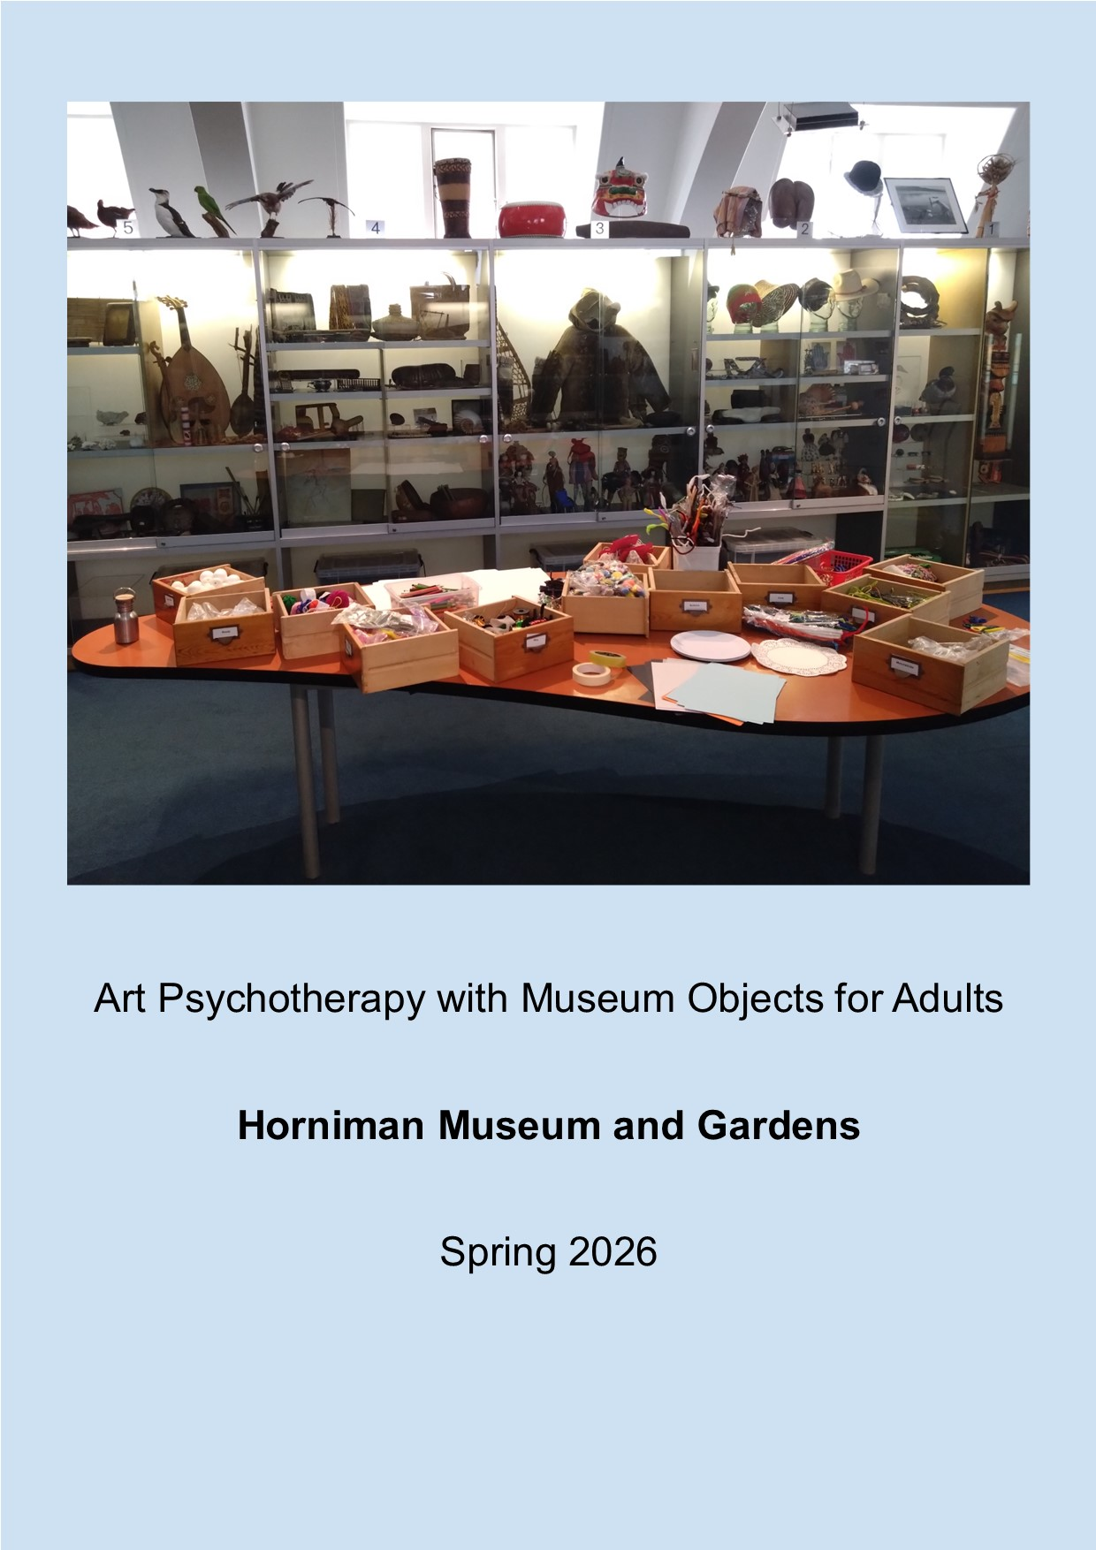

On Wednesday afternoons (2.30 – 4pm) between Wednesday 15th April and Wednesday 17th June 2026 the Horniman Museum and Gardens is running an Art Psychotherapy programme using museum objects for people living with social isolation and/or mental ill health at the Horniman Museum.
There will be a group of up to 8 people. You will make art and handle museum objects to explore your thoughts and feelings. You can share these in the group if you would like to. No experience or expertise in art is needed. We ask that you do your best to attend all the sessions so that you can make the most of the experience.

What?
- Art making with dry materials (such as pencils and paper but also wire and fabric scraps)
- Choosing and handling objects in the Horniman’s handling collection based on your personal connection to them
- Showing your artwork and talking about the object you chose and the artwork you made with the group (if you would like to)
- Seeing what other people in the group have chosen and made, to understand different points of view and other possibilities for expressing ourselves
- Getting to know other members of the group to connect with others and understand different ways of seeing things
Who?
- For adults (must be 18+) who are able to access the Horniman Museum independently (see Access below)
- For anyone whose health and wellbeing may benefit from being part of a group where we explore and share feelings using artmaking and museum objects
- For people who can attend on the dates below. This is important for us all to form a strong group and make the most of the programme.
- People with a basic understanding of spoken English welcome
- Suitable for people living with lower-risk mental health conditions such as low mood, anxiety or depression who can access activities independently.
- Not suitable for people with serious mental health conditions or very high support needs
- Not a drop-in for groups – but we can arrange separate group visits to do similar activities.
Where?
Horniman Museum and Gardens, 100 London Rd, SE23 3PQ.
The meeting point for sessions is outside the Hands On Base (see images 1 and 5 below), just inside the main museum entrance. Most sessions will be held in Hands On Base.

When?
Every Wednesday from 2.30 – 4pm between Wednesday 17th April and Wednesday 17th June 2026.
Accessibility
- The Horniman is fully accessible from the main public entrance on London Road (see image 2 below).
- The path from the main gate to the Museum entrance (see image 3 below) is approximately 150 meters long and is uphill. There are benches to rest along the way.
- The main entrance is to the right of the path (see image 4 below).
- There are two sets of automatic glass doors at the entrance.
- There are chairs to rest on inside the main museum entrance
- Only Blue Badge holders can park onsite. The Horniman has 3 non-bookable Blue Badge parking bays. If they are full, drop-off is possible on-site but subsequent parking would be in the surrounding residential areas.
- More access info here: https://www.horniman.ac.uk/plan-your-visit/access/
Transport
- Bus. The 176, 185, 197, 356 and P4 stop outside the Museum and Gardens on London Road. The P13 and 363 stop nearby.
- Train. The Horniman is a ten minute walk from Forest Hill station and is signposted from the platform 1 exit (towards London Road, not Perry Vale). Please be aware this walk is uphill, although 176, 185, 197 and 356 bus services stop at both the station and Museum.
- Bicycle: There are bicycle racks outside the Library building. Please don’t ride your bicycle or e-scooter in the gardens
Costs
- There are no costs other than travelling to the Horniman and all art materials will be provided.
Referral/contact
Please refer by email or phone to Julia Cort: jcort@horniman.ac.uk 020 8161 3485
When referring someone, we need:
- The person’s name and preferred contact details
- Consent for us to contact them
- Any known access requirements
Before the first session, we will ask participants to:
- have a short assessment conversation with the Art Psychotherapist (by phone or in person)
- fill in a consent form
- provide next-of-kin details

Images
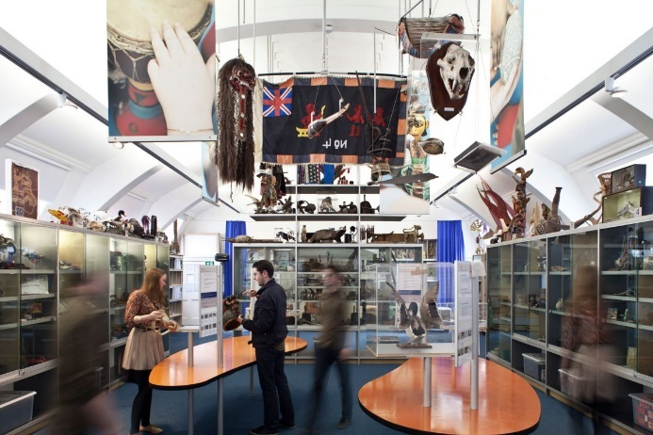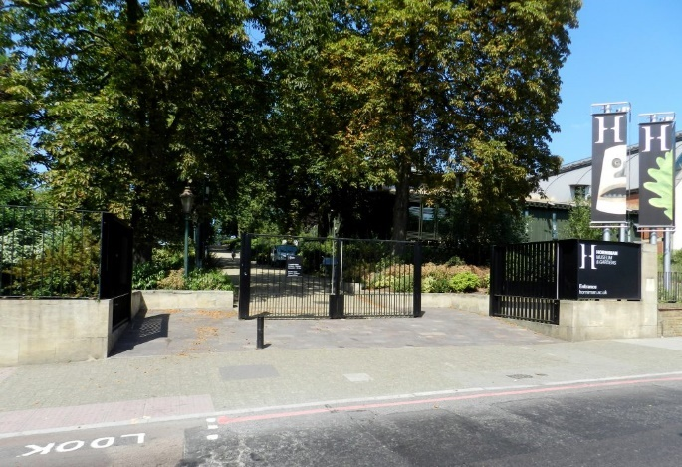
Image 1: The Hands On Base Image 2: Horniman main gate from London Road
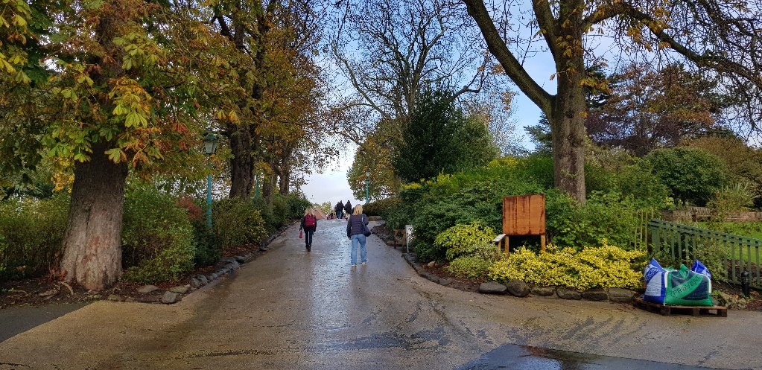
Image 3: The hill in the Horniman gardens reaching approximately 90m elevation, steepest gradient approximately 1:9.
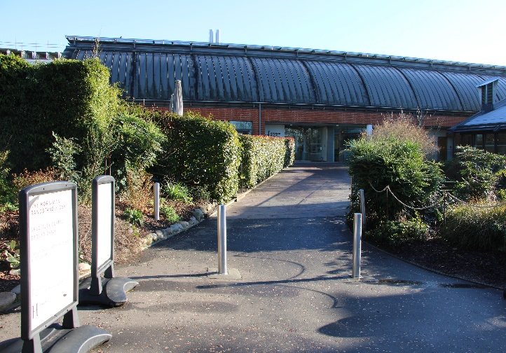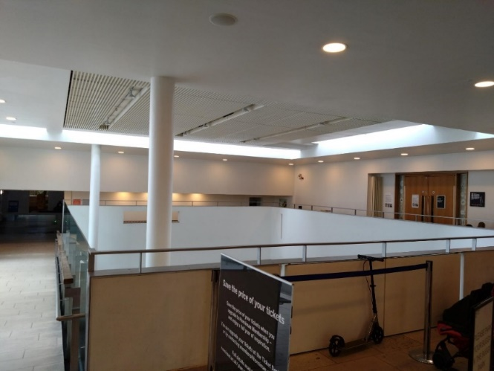
Image 4: main entrance to Horniman Museum Image 5: Doors to the Hands On Base on the
right, as seen from main entrance.

