

Policy for use of Lewisham Nature Reserves by Schools/Nurseries for Forest Schools/Education
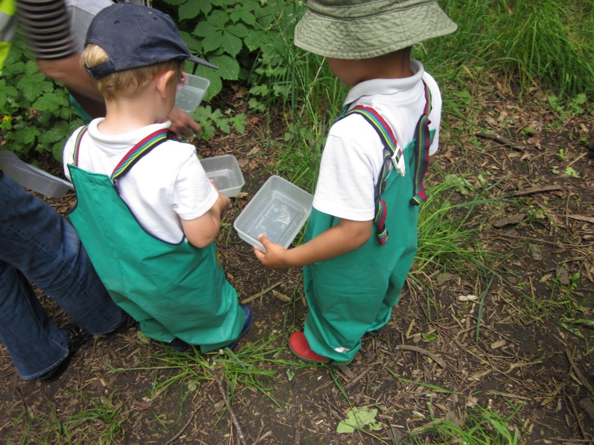

The London Borough of Lewisham encourages outdoor learning and is keen to work in partnership with schools to provide classes relevant to the National Curriculum. The council’s Nature Conservation Officer can offer facilitated sessions to local schools in Habitat Studies on a number of sites throughout the Borough.
We also understand that schools are keen to use our sites independently and possibly on a more regular basis. We have therefore produced a working document on the arrangements for this. It includes
- What is a Forest School?
- The process of choosing who can use Lewisham’s sites.
- Environmental considerations
- Health & Safety/Safeguarding
- What we expect from the schools/nurseries in return
- The costs associated with using the sites.
- The relevant paperwork needed to be completed before we allow access to the site.
- The length of time access will be granted.
- The review period for access
- Breaching of guidelines/code of conduct

- What is a Forest School (FS)?
“A Forest School is an innovative educational approach to outdoor play and learning.” (Sarah Blackwell)
The philosophy of Forest Schools is to encourage and inspire individuals of any age through positive outdoor experiences. By participating in engaging, motivating and achievable tasks and activities in an outdoor environment each child has an opportunity to develop intrinsic motivation, sound emotional and social skills. These, through self-awareness can be developed to reach personal potential.
Forest Schools have demonstrated success with children of all ages through play, learning about the natural environment, how to handle risks and most importantly to use their own initiative to solve problems and co-operate with others.
Forest School Principles (Forest School Association, 2012):
- FS is a long-term process of regular sessions, rather than a one-off or infrequent visits; the cycle of planning, observation, adaptation and review links each session.
- FS takes place in a woodland or natural environment to support the development of a relationship between the learner and the natural world.
- FS uses a range of learner-centred processes to create a community for being, development and learning.
- FS aims to promote the holistic development of all those involved, fostering resilient, confident, independent and creative learners.
- FS offers learners the opportunity to take supported risks appropriate to the environment and to themselves.
- FS is run by qualified Forest School practitioners who continuously maintain and develop their professional practice.

- The process of choosing which schools or nurseries can use the site.
Any group wishing to use a site must first fill out a Lewisham Council Forest Schools Hire Form (attached). All questions must be answered in full or your place will not be considered. Forms will be evaluated by Lewisham’s Nature Conservation Team and a decision made considering order of application and the following criteria:
- Priority will be given to Lewisham nurseries/schools.
- Relevant and robust processes in place (e.g. risk assessment, safeguarding)
- Activities proposed.
- Monitoring/mitigating measures proposed.
If an application is accepted a Lewisham Forest School Licence will be prepared and signed.

- Environmental considerations
Leave no trace!
One of the principles of Forest School is to promote environmental awareness and encourage sustainability. Children are taught about respect and responsibility for the world around them. Both children and adults are encouraged to value their environment and to be aware of conservation issues of the area they are using.

Encouraging children to care for the environment is an essential part of the Forest School philosophy. In order to encourage the children to look after the site, groups will always need to leave it tidy and never damage anything growing in it. Groups will only collect things that are on the ground and leave the area as they found it when they leave. Nothing is to be left on site.
An appointed or designated ‘Forest School Leader’ is responsible for monitoring the site so that these considerations are met. Please note that if we become aware that these considerations have not been met, we reserve the right not to renew the licence at the next review or to terminate the licence with 4 weeks written notice (see point 10. Breaching of guidelines/code of conduct below).

- Health & Safety/Safeguarding
The Forest School curriculum supports children to develop responsibility for themselves and others. It encourages early risk management strategies that ensure that children start to consider the impact of their actions on themselves and on others. For this reason:

- A detailed site risk assessment should be carried out before any activities commence, and a copy held in the Leader’s file and by the London Borough of Lewisham’s Nature Conservation Team.
- The Forest School Leader, or another responsible person participating in the activity, should have an up-to-date certificate in Outdoor First Aid and will be in charge of all first aid arrangements (including an in-date first aid kit). A copy of the First Aid certificate should be held in the Leader’s file and by the London Borough of Lewisham’s Nature Conservation Team.
- Fires or BBQs are only permitted if written consent is given by the Council for trained Learning Provider(s) with relevant insurance cover.
- Safety Sweep and Checklists - The Forest School Leader must carry out a thorough sweep of the site for any observable hazards and risks before the visiting group enters the site. Appropriate measures should be in place to deal with any hazards, e.g. removal of an object (including obstructive or offensive), or warning the group of specific dangers related to the site. We would also strongly encourage the Leader or the school/nursery to contact us to report any hazards or obstructions which had to be removed or dealt with, so we can rectify any problems for future visits and activities.

- What we expect from the schools/nurseries in return
For sites where there are Friends Groups, we expect one of the leaders to either attend one meeting a year (out of 4) to give an update on the activities they have been doing on site and/or produce a document showing these activities which should include the number of visits taken and the number of children engaged.
We would also ask that they help with the marketing of the Open Days or other events through school newsletters and posters.
- The costs associated with using the sites.
In spite of everyone’s best intentions, Forest Schools have a large impact on sites. There are always costs associated with this which is why we have taken the decision to charge for the use of our sites. All money received will be spent directly on the given reserve. We also welcome suggestions from Forest School leaders on how they think this income could be spent and advise them to put a proposal together to take to the Friends Group meetings where suggestions can be discussed.

 | LBL State Schools and Academies | LBL Non-state schools and fee paying education providers’ | Non-LBL schools and Non-LBL nurseries
Occasional hire without building | Free | £16/hr | £21/hr
Occasional hire of sites using building | Free | £21/hr | £24/hr
Hire of site for term/ full academic year | Free | Price on application | Price on application

- The relevant paperwork needed to be completed before we allow access to the site

  - Proposal for use of the site (see attached hire form)
  - Hire Form (attached)
  - Environmental Impact Assessment
  - Public Liability Insurance (see attached hire form)
  - Risk Assessment (examples attached)
  - COVID-19 Secure Risk Assessment
  - Proof of DBS
  - Signed Forest School licence (attached)
  - Certification of all practitioners.
  - Dates and times of hire

- The length of time access will be granted.
The licence to run a Forest School will be granted yearly. Site inspections will occur termly with a London Borough of Lewisham Officer and the Forest School leader to assess the level of impact the sessions have had on the site and to ensure that the licence has been followed. (See also section 10. Breaching of this policy/code of conduct).
- The review period for access
The review period for access will be yearly. It should be noted that the re-granting of the Forest School licence is not guaranteed. There is a high demand for our sites to run Forest Schools and Schools/Nurseries should not assume the site is available for their use in perpetuity.
- Breaching of this policy/code of conduct
Please note that if we become aware that these considerations have not been met, we reserve the right not to renew the licence at the next review or to terminate the licence with 4 weeks written notice. If there has been a serious breach, then the London Borough of Lewisham reserve the right to revoke the licence at any time with immediate effect.

- If the Learning Provider(s) decide that they wish to terminate the agreement before the end of the licence, they shall write to London Borough of Lewisham giving a terms notice of their intention to do so.
- Lewisham Council Access during booked sessions

Lewisham Council will to everything they can to ensure that any maintenance work is carried out when there is nobody on site. There will however, be occasions where this is not possible, such as an emergency with the boiler and other health and safety issues. Lewisham Council will inform the user if this is the case so that alternative arrangements can be made if necessary.

- Cancellations and Refunds

The Learning Provider is required to notify the Council of any cancellations as soon as possible stating the reason. You may cancel up to two weeks before the scheduled event and receive a full refund in case the cancellation is due to events out of the Learning Provider's control (e.g. weather, site health and safety issue). If cancellation is received after the two-week time period or if the session is cancelled for any other reason including, but not limited to staff shortage, low attendance, no refund will be issued. The refund will be issued in the form of a discount in the following quarter’s invoice.

- Providing the dates and times of hire

The Council will request the dates on which the Learning Provider(s) wish to hire the site on a quarterly basis. This is to ensure that the Learning Provider(s) is invoiced correctly (where applicable) and to ensure the site is not hired out to another group. Please note failure to provide these dates in a timely manner may result in the padlock code being changed and the relevant Learning Provider(s) will not have access to the site until the dates have been submitted.

- Ropes and swings in trees

For safety reasons, we kindly ask that groups refrain from attaching ropes, swings, or any other equipment to climb trees. While trees may seem sturdy, attaching such items can put undue stress on the branches, potentially causing them to snap and leading to serious injury.

Contact

For more information or to enquire about using Lewisham’s Nature Reserves for Forest School or other organised educational/environmental activities, including guided or supervised walks/talks and volunteering sessions, please contact using the details provided below.

Telephone: 020 8314 2119
Email: jessica.kyle@lewisham.gov.uk
Web: www.lewisham.gov.uk

