What is in Soil?
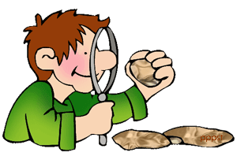
Soil is formed of fine rock particles mixed with air, water and particles from dead plant and animal matter. There are three main types of soil which are classified according to the amount of sand and clay in them. (Sand, silt and clay). Soil is made up of sand, silt, clay, air, water, organic matter and animals and they all have an important job!
What’s in Soil? |  | Why is it important?
SAND – Drains well, but cannot hold on to nutrients |  | Sand is an important part of the soil because it provides drainage
SILT – Can hold water, but can be hard to drain. Can hold on to limited nutrients |  | Silt is an important part of the soil because it holds on to limited nutrients and holds on to water.
CLAY – Holds on to water well but can become heavy and waterlogged when wet. Can hold nutrients |  | Clay is an important part of the soil because it holds on to water well and can hold nutrients
AIR – Fills all the gaps in the soil and allows plant roots and animals to breathe 35-40% of good soil is air. |  | Air is an important part of the soil because it allows plants and animals to breathe.
WATER – Clings on to soil particles and is taken up by the plant roots |  | Water is an important part of the soil because without it the plants and animals would die.
ORGANIC MATTER – Releases nutrients slowly as it rots and improves water holding. It includes manure, leaf mold and compost |  | Organic Matter is an important part of the soil because helps stick the soil together
ANIMALS – Include insects, bacteria and worms |  | Animals are an important part of the soil because they help rot down dead material
Important vocabulary
Nutrients: Needed by the plants to grow
Organic matter: Dead or decaying matter found at the top of soil. This lies just on top of
the topsoil.
Drainage: removes excess water from the soil-water that prevents air and oxygen from getting
to plant roots.

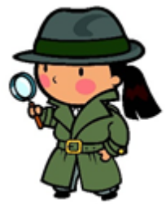

See also
- A Teachers Guide 8 – A Teachers Guide to Rocks and Soils
- A Teachers Guide 10 – A Teachers Guide to the soil experiment
- A Teachers Guide 11 – A Teachers Guide to the Rock Cycle
- A Teachers Guide 12 – Rocks and Soils Glossary

