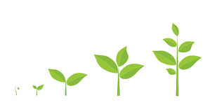PLANTS
Plants are living organisms that cover much of the land of planet Earth. You see them everywhere. They include grass, trees, flowers, bushes, ferns, mosses, and more. Plants are members of the kingdom plantae. There are many different kinds of plants. Some have flowers. Some don’t. Some give us fruits. Some give us vegetables. Some plants are poisonous, some have thorns and some are food for animals.
Even though there are so many different kinds of plants, there are several things about plants that are alike. Let’s look at some of the ways plants are alike:
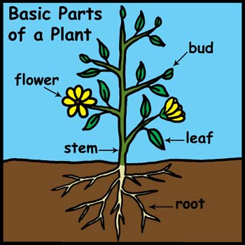
- Plants start from seeds (most of them, anyway)
- Plants have roots
- Plants have stems
- Plants have leaves
- Plants need air, sun and water to live
- Plants make their own food (photosynthesis)
- All plants give us oxygen

- Strawberry is the only fruit that bears its seeds on the outside. The average strawberry has 200 seeds!
- More than 30,000 Plant Species Are Used as Medicine in the World
- Flowers did not always exist; they first appeared 140 million years ago. Before that, ferns and cone bearing trees dominated the earth.
- The first potatoes were cultivated in Peru about 7,000 years ago!

- Of Earth’s estimated 400,000 plant species, we could eat some 300,000, armed with the right imagination, boldness and preparation. Yet humans, possibly the supreme generalist, eat a mere 200 species

