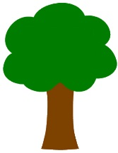
TREES

- The main thing to know about forest and woodland habitats is that they are areas that have a lot of trees pretty close to each other.
- Woodlands are a little more open than forests – woodlands have space to let a bit of light in between trees, while forests have so many trees that it’s actually pretty dark when you walk around.
- Trees can grow pretty much anywhere in the world, as long as it’s in a spot that has enough water for them. Because of that, forest habitats can be very different depending where in the world they are.
- There are many different kinds of trees, but a couple of the main groups are coniferous trees and deciduous trees.
- Coniferous trees are trees that produce seeds in cones, like pine trees and spruce trees (Christmas trees!)
- Deciduous trees are trees that lose their leaves in the winter, but grow them back in the summer.
- Fruits and nuts found in the forest make a perfect meal for animals who live there, so they don’t have to search too far to find food.
- Forests also provide shelter for animals, whether it’s within the tree roots or trunks, or high up in the branches.
- Animals that live in forests and woodlands include big animals like bears, moose and deer, and smaller animals like hedgehogs, raccoons and rabbits.
- Because we use trees to make paper, we need to be careful about what that does to forest habitats. One way to care for forests is to recycle paper.
- Trees grow pretty much everywhere, but not all trees are the same. Two main groups of trees are:
- Coniferous – conifers are trees that grow cones and have thin, needle-like or scaly spikes for leaves, which is where their seeds are stored; pine trees, fir trees and spruce trees are conifers (and they are the kind of trees that we decorate at Christmas!)
- Deciduous – deciduous trees have flat leaves that change colours in the autumn, fall off in the winter, and grow back in the spring; oak trees and maple trees are deciduous
- Animals and insects who live in forest and woodland habitats rely on the trees to give them what they need – shelter, food, and protection from other creatures higher up the food chain.
- Conkers are the seeds of a deciduous tree called a horse chestnut tree.
- Acorns are the seeds of a deciduous tree called an oak tree.
Important vocabulary
Coniferous: conifers are trees that grow cones and have thin, needle-like or scaly
spikes for leaves, which is where their seeds are stored. Coniferous trees stay green
all year and are also called ‘evergreen’
Deciduous: deciduous trees have flat leaves that change colours in the autumn, fall
off in the winter, and grow back in the spring; oak trees and maple trees are deciduous

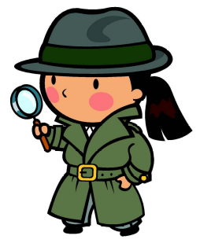
Start your trial for £1.97 today!
Access thousands of brilliant resources to help your child be the best they can be.

Forest and woodland habitats10 facts

Did you know?

