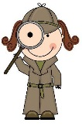
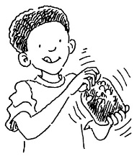
Soil is made up of a mixture of sand, silt, clay and rotted plant (organic) material. Different soil types have differing percentages of each. The jam-jar soil experiment will help you determine the proportions/ percentages of each of these in the soil in your local park or nature reserve.
Step 1
Take a clean, straight-sided jam jar and fill it about a third of the way up with the soil you are experimenting with. Also have ready another jar of clean water.
Step 2
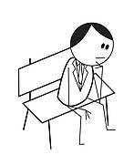
Now add water to your jam jar until it is almost full and shake the jar (if there is a lid on it) or mix it thoroughly with a stick if not!
Step 3
Wait! While we wait we’ll have a look at our other worksheet while the soil has
time to settle!
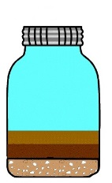
Step 4
Once the water has settled, different layers should appear. Sand particles are the biggest and weigh more than the other layers, so they will be on the bottom along with any pebbles/rocks. The silt layer should be next because they weigh less than sand. Finally any organic matter in the mixture will be at the top.
Working the percentage
Example:
A1 = 20cm
A2 = 2cm
$∴$ 2÷20x100 = 10%
 |  | A | B
1 | Using a measuring tape measure the total height of the water and soil – put the answer here | cm
2 | Using a measuring tape measure the total height of layer 1 – put the answer here | cm | %
3 | Using a measuring tape measure the total height of layer 2 – put the answer here | cm | %
4 | Using a measuring tape measure the total height of layer 3 – put the answer here | cm | %
5 | Using a measuring tape measure the total height of layer 4/water – put the answer here | cm | %

Now A2 ÷ A1 x 100 put the answer in column B2.
A3 ÷ A1 x 100 put the answer in column B3
A4 ÷ A1 x 100 put the answer in column B4

What’s in Soil? |  | Why is it important?
AIR – Fills all the gaps in the soil and allows plant roots and animals to breathe 35-40% of good soil is air. |  | Air is an important part of the soil because it allows plants and animals to breathe.
ORGANIC MATTER – Releases nutrients slowly as it rots and improves water holding. It includes manure, leaf mold and compost |  | Organic Matter is an important part of the soil because helps stick the soil together
ANIMALS – Include insects, bacteria and worms |  | Animals are an important part of the soil because they help rot down dead material
WATER – Clings on to soil particles and is taken up by the plant roots |  | Water is an important part of the soil because without it the plants and animals would die.
SILT – Can hold water, but can be hard to drain. Can hold on to limited nutrients |  | Silt is an important part of the soil because it holds on to limited nutrients and holds on to water.
SAND – Drains well, but cannot hold on to nutrients |  | Sand is an important part of the soil because it provides drainage
CLAY – Holds on to water well but can become heavy and waterlogged when wet. Can hold nutrients |  | Clay is an important part of the soil because it holds on to water well and can hold nutrients
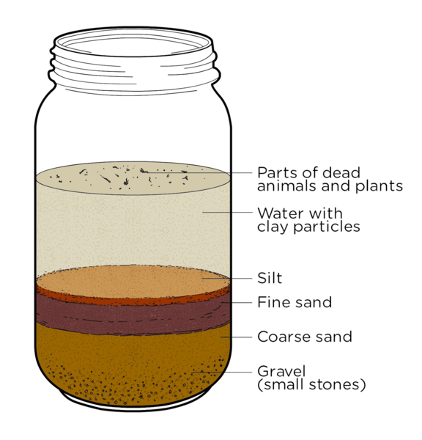

Surface Layer | This is the top layer of soil that is made up of living and decomposed materials like leaves, plats and bugs. The layer is quite thin and usually dark!
Top Soil | This layer is made up of minerals and decomposed organic matter and is also dark in colour. Many plants grow in this layer.
Subsoil | This layer has clay and mineral deposits and less organic materials than they layers above. It is also lighter in colour than the layers above it.
Parent Material | This horizon is the parent material from which the upper soil layers developed. It consists primarily of large rocks.
Bedrock | This is the bedrock and is located several meters under the surface. The bedrock is made up of a solid mass of rock.
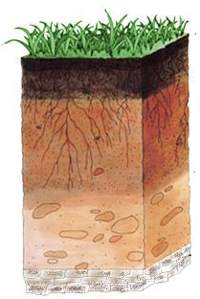

See also
- A Teachers Guide 8 – A Teachers Guide to Rocks and Soils
- A Teachers Guide 9 – A Teachers Guide to soil
- A Teachers Guide 11 – A Teachers Guide to the Rock Cycle
- A Teachers Guide 12 – Rocks and Soils Glossary

