
Title: Rocks and Soils Worksheet - The Rock Cycle
Subject: Science/Maths
The Earth's rocks do not stay the same forever. They are continually changing because of processes such as weathering and large earth movements. The rocks are gradually recycled over millions of years. This is called the rock cycle. For example sedimentary rocks can be changed into metamorphic rocks, and these can be weathered and the pieces transported away. These pieces could be deposited in lakes or seas and eventually form new sedimentary rock. Many routes through the rock cycle are possible.
Look at the diagram below, and using the following words, fill in the blanks. Then answer the questions.
Magma Sedimentary Rock Sediment Igneous Rock Metamorphic Rock
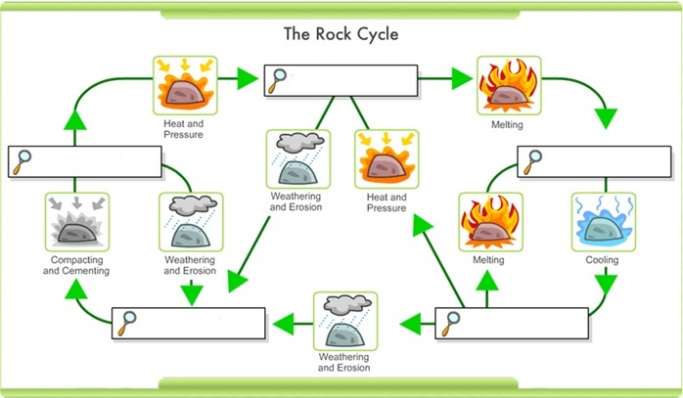

- What type of rock forms what magma cools and solidifies

- What type of rock is formed by heat and pressure?

- What type of rock is formed by sediment that is deposited over time, usually as layers at the bottom of lakes and oceans?
Important vocabulary and Teacher’s Guides
Sedimentary rock: Sedimentary rocks are formed from sediments that have settled at the bottom of a lake,
sea or ocean, and have been compressed over millions of years.
Metamorphic rock: Metamorphic rocks have been subjected to tremendous heat and/or pressure, causing
them to change into another type of rock.
Igneous rock: Igneous rocks are formed by magma from the molten interior of the Earth.
A Teachers Guide 11 – A Teachers Guide to the Rock Cycle



