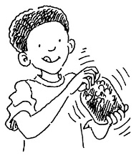
Title: Rocks and Soils worksheet 039 - Observing and describing soil
Subject: Science/Maths

Soil is made up of a mixture of sand, silt, clay and rotted plant (organic) material. Different soil types have differing percentages of each. The jam-jar soil experiment will help you determine the proportions/ percentages of each of these in the soil in your local park or nature reserve.
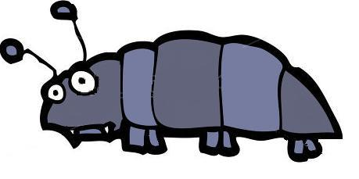
Further work: Why don’t you try the experiment with soil from your school grounds and compare your results?

I can see | Yes | No
Leaves
Stones
Twigs
Plants
Living Creatures
Sand
Water (place bottle on blotting paper)
Air (soil in bottle cap lowered into water)
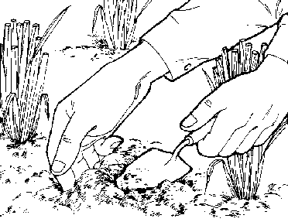
Draw a picture of your soil

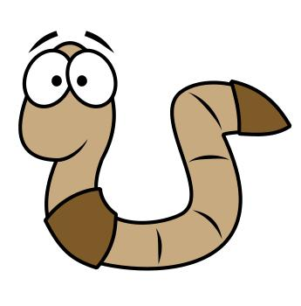

My soil feels ________________________________________________________________________________________________

These are the colours I see _________________________________________________________________________________________________
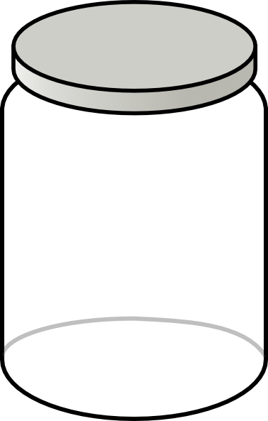
What does soil contain?

Teacher’s Guides and Further Learning
- A Teachers Guide 8 – A Teachers Guide to Rocks and Soils Rocks and Soils – Rocks quiz 036
- A Teachers Guide 9 – A Teachers Guide to soil Rocks and Soils – Rocks and Soils fact file 037
- A Teachers Guide 10 – A Teachers Guide to the soil experiment Rocks and Soils – Soils Quiz 038
- A Teachers Guide 11 – A Teachers Guide to the Rock Cycle Rocks and Soils – Observing and describing soil 039
- A Teachers Guide 12 – Rocks and Soils Glossary Rocks and Soils – The Rock Cycle 040



