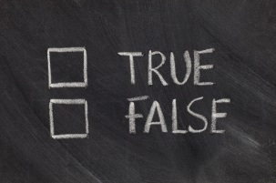
Title: Rocks and Soils Worksheet – Soil Quiz Questions True or false
Subject: Science

Question | True | False
Animals need soil to stay alive

Plants would not be here if there was no soil

Soil comes from the sea

It takes 1000 years to make an inch of soil

Clay is a type of food

All types of soil feel and look the same

Sandy soil feels dry and light

Plants can grow and survive in all types of soil

Earthworms are the only creatures that live in soil

Soil on ground contains air


Teacher’s Guides and Further Learning
A Teachers Guide 9 – A Teachers Guide to soil
A Teachers Guide 11 – A Teachers Guide to the Rock Cycle
A Teachers Guide 12 – Rocks and Soils Glossary
Rocks and Soils – Rocks quiz 036
Rocks and Soils – Rocks and Soils fact file 037

