
Title: Rocks and Soils Worksheet 040a Rocks fact file - ANSWERS
Subject: Science

Look at the images of different types of rocks below and then answer the questions next to the picture to help you describe the rock.

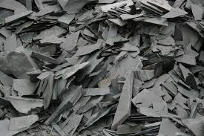 | Name of rock: Slate  Texture: Hard, smooth  Type of rock: Metamorphic  Used for: Roofing, flooring, cladding, chalkboards, billiard tables
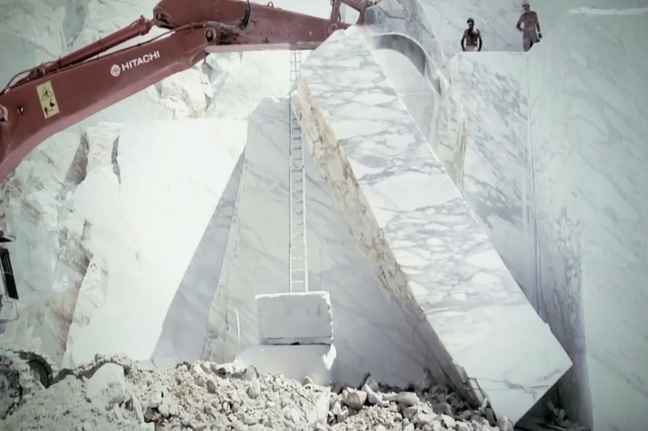 | Name of rock: Marble  Texture: Smooth, hard  Type of rock: Metamorphic  Used for: Monuments, buildings, sculptures, paving (Taj Mahal, David, Parthenon)
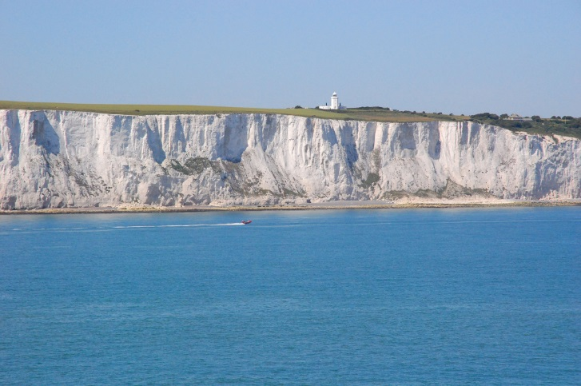 | Name of rock: Chalk  Texture: Soft  Type of rock: Sedimentary  Used for: Raising pH in soils, toothpaste, weightlifting, fingerprints (Needles, White cliffs of Dover)
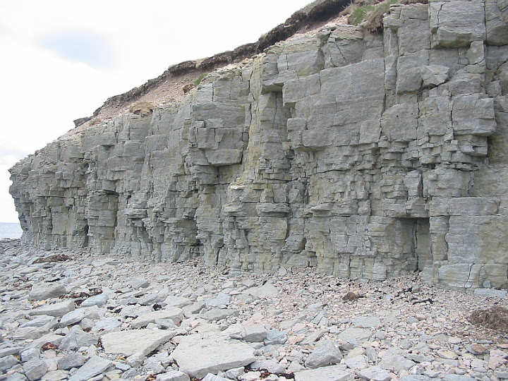 | Name of rock: Limestone  Texture:  Type of rock: Sedimentary  Used for: Crushed to be used in construction, smelting & metal refining, Powdered – filler in paint, paper, rubber and plastic (Sphinx & parts of Empire State building)
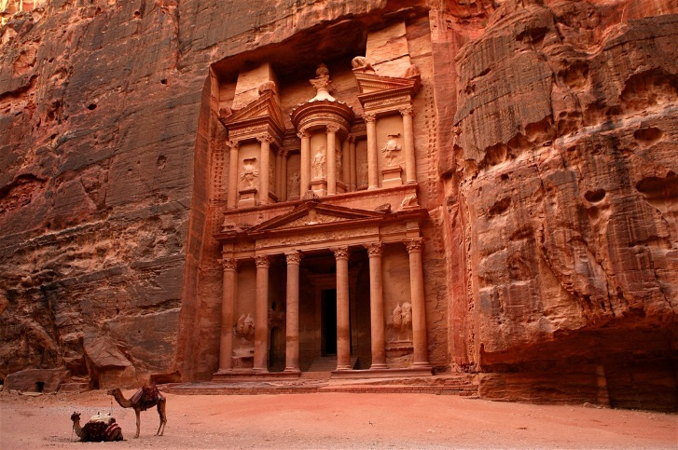 | Name of rock: Sandstone  Texture: Soft (ish) (depending on type), rough, porous  Type of rock: Sedimentary  Used for: Construction, paving (Luxor Temple, Petra)
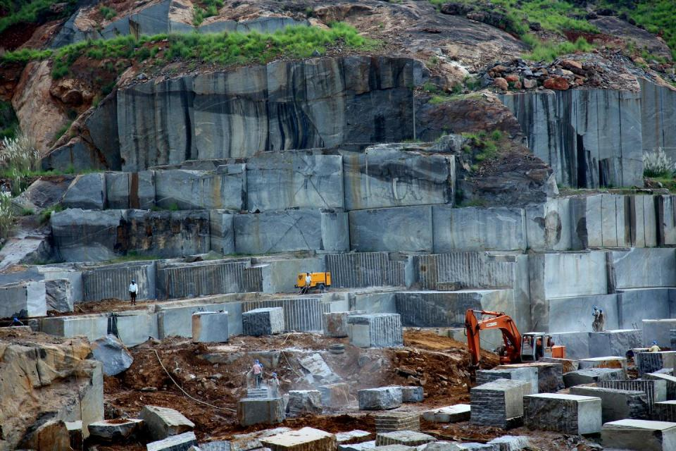 | Name of rock: Granite  Texture: Hard, course  Type of rock: Igneous  Used for: Countertops, tile floors (Mt. Rushmore)

Important vocabulary
Sedimentary rock: Sedimentary rocks are formed from sediments that have settled at the
bottom of a lake, sea or ocean, and have been compressed over millions of years.
Metamorphic rock: Metamorphic rocks have been subjected to tremendous heat and/or
pressure, causing them to change into another type of rock.
Igneous rock: Igneous rocks are formed by magma from the molten interior of the Earth.

Important vocabulary

