
Title: Worksheet 1 – Rocks fact file
Subject: Science

Look at the images of different types of rocks below and then answer the questions next to the picture to help you describe the rock.

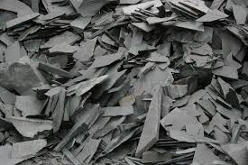 | Name of rock:  Texture:  Type of rock:  Used for:
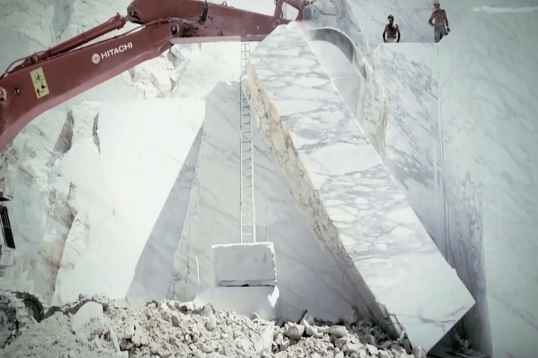 | Name of rock:  Texture:  Type of rock:  Used for:
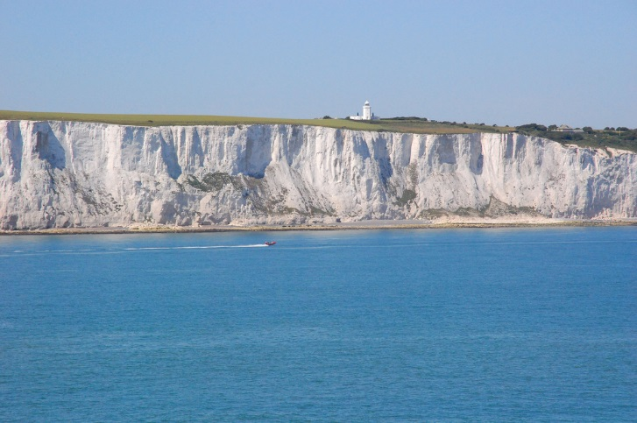 | Name of rock:  Texture:  Type of rock:  Used for:
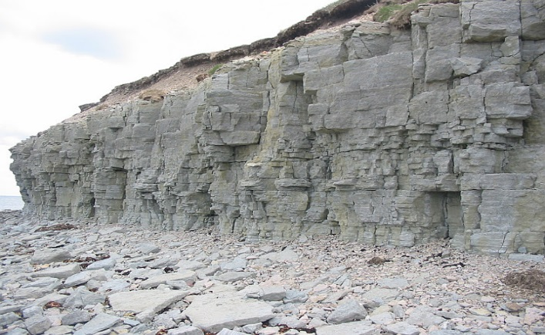 | Name of rock:  Texture:  Type of rock:  Used for:
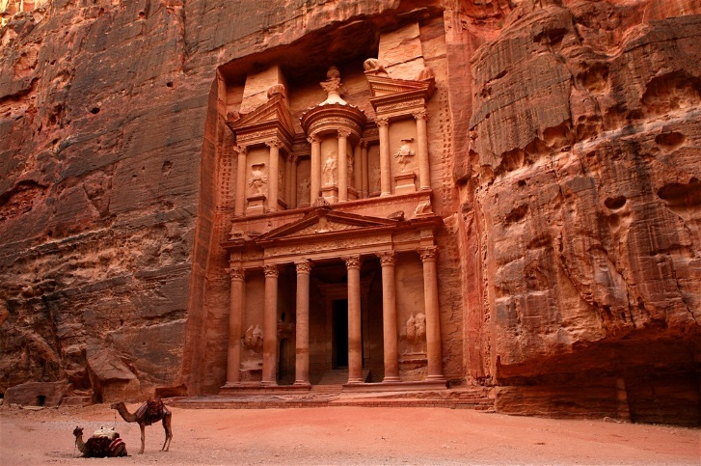 | Name of rock:  Texture:  Type of rock:  Used for:
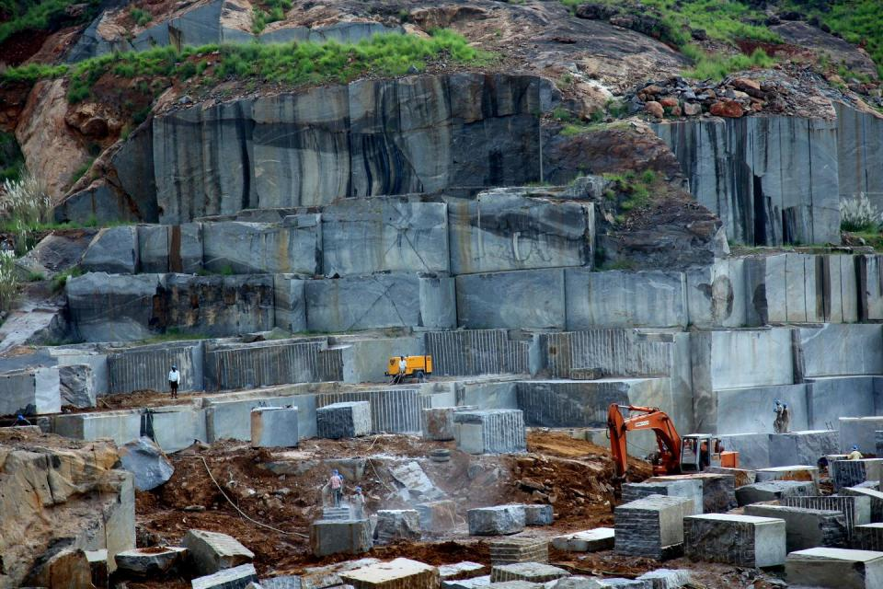 | Name of rock:  Texture:  Type of rock:  Used for:
Important vocabulary, Teacher’s Guides and Further Learning
Sedimentary rock: Sedimentary rocks are formed from sediments that have settled at the bottom of a lake,
sea or ocean, and have been compressed over millions of years.
Metamorphic rock: Metamorphic rocks have been subjected to tremendous heat and/or pressure, causing them
to change into another type of rock.
Igneous rock: Igneous rocks are formed by magma from the molten interior of the Earth.

A Teachers Guide 8 – A Teachers Guide to Rocks and Soils
A Teachers Guide 12 – Rocks and Soils Glossary
Rocks and Soils – Rocks quiz 036
Rocks and Soils – Soils Quiz 038
Rocks and Soils – Observing and describing soil 039 (Jam Jar experiment)
Rocks and Soils – The Rock Cycle 040


Important vocabulary

