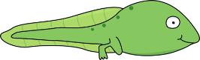
Title: Living Things worksheet– Life Cycles Quiz (Answers)
Subject: Science

Question | True | False
Mammals lay eggs |  | ✓
Germination is the process by which a plant begins to grow from a seed | ✓
Pollen produced by a flower is carried by insects or blown by the wind to another flower. | ✓
An adult caterpillar is called a ladybird |  | ✓
The first stage of reproduction in flowering plants is called ‘pollination‘. | ✓
Sepals are the part of the plant which attract insects |  | ✓
Insect pollinated plants have dull colours and little smell |  | ✓

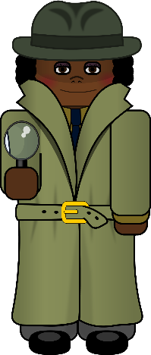

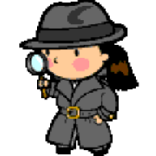
Important vocabulary
Pollination is a very important part of the life cycle of plants. Insects, birds, bats and the wind take
pollen between flowering plants, which means the plants can make seeds and reproduce.
Important vocabulary

Habitat: A place where an animal lives and gets food, shelter & water
Insects: Have six legs. They have three body parts,
a head, a thorax and an abdomen.
Flora: All plants and fungi in an environment
Fauna: The animals that live in an environment

Important vocabulary

Habitat: A place where an animal lives and gets food, shelter & water
Insects: Have six legs. They have three body parts,
a head, a thorax and an abdomen.
Flora: All plants and fungi in an environment
Fauna: The animals that live in an environment

Important vocabulary

Habitat: A place where an animal lives and gets food, shelter & water
Insects: Have six legs. They have three body parts,
a head, a thorax and an abdomen.
Flora: All plants and fungi in an environment
Fauna: The animals that live in an environment

Important vocabulary

Habitat: A place where an animal lives and gets food, shelter & water
Insects: Have six legs. They have three body parts,
a head, a thorax and an abdomen.
Flora: All plants and fungi in an environment
Fauna: The animals that live in an environment

Important vocabulary

Habitat: A place where an animal lives and gets food, shelter & water
Insects: Have six legs. They have three body parts,
a head, a thorax and an abdomen.
Flora: All plants and fungi in an environment
Fauna: The animals that live in an environment

Important vocabulary

Habitat: A place where an animal lives and gets food, shelter & water
Insects: Have six legs. They have three body parts,
a head, a thorax and an abdomen.
Flora: All plants and fungi in an environment
Fauna: The animals that live in an environment

