
Title: Living Things worksheet 4 –Pollination Quiz
Subject: Science/Maths

Question | True | False
The first stage of reproduction in flowering plants is called ‘pollination‘. (it’s germination) |  | ✓
Pollen is produced on the petals |  | ✓
Flowers are pollinated — by insects and by the wind | ✓
Birds and bats can pollinate plants | ✓
Insect pollinated plants have dull colours and little smell |  | ✓
Dandelions use the wind to spread their seeds (or parachutes) | ✓
Some plants have exploding pods which scatter their seeds when they burst open. | ✓
Sepals are the part of the plant which attract insects |  | ✓

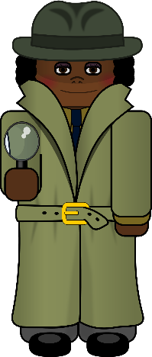

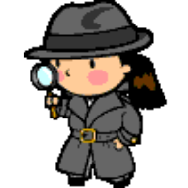
Important vocabulary
Pollination: This is when the pollen produced on the anther of a flower moves to the stigma.
Wind-pollinated flowers: these flowers are usually a green or dull colour and have no scent,
since there is no need to attract insects.
Insect-pollinated flowers: these flowers have brightly coloured petals and are scented with
sweet-smelling nectar to attract insects looking for a snack.
Important vocabulary

Habitat: A place where an animal lives and gets food, shelter & water
Insects: Have six legs. They have three body parts,
a head, a thorax and an abdomen.
Flora: All plants and fungi in an environment
Fauna: The animals that live in an environment

Important vocabulary

Habitat: A place where an animal lives and gets food, shelter & water
Insects: Have six legs. They have three body parts,
a head, a thorax and an abdomen.
Flora: All plants and fungi in an environment
Fauna: The animals that live in an environment

Important vocabulary

Habitat: A place where an animal lives and gets food, shelter & water
Insects: Have six legs. They have three body parts,
a head, a thorax and an abdomen.
Flora: All plants and fungi in an environment
Fauna: The animals that live in an environment

Important vocabulary

Habitat: A place where an animal lives and gets food, shelter & water
Insects: Have six legs. They have three body parts,
a head, a thorax and an abdomen.
Flora: All plants and fungi in an environment
Fauna: The animals that live in an environment

Important vocabulary

Habitat: A place where an animal lives and gets food, shelter & water
Insects: Have six legs. They have three body parts,
a head, a thorax and an abdomen.
Flora: All plants and fungi in an environment
Fauna: The animals that live in an environment

Important vocabulary

Habitat: A place where an animal lives and gets food, shelter & water
Insects: Have six legs. They have three body parts,
a head, a thorax and an abdomen.
Flora: All plants and fungi in an environment
Fauna: The animals that live in an environment

