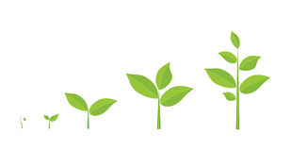
Title: Living Things - Plant parts and function (Answers)
Subject: Science/Maths

Date _______________________ Name______________________ Site ____________________________
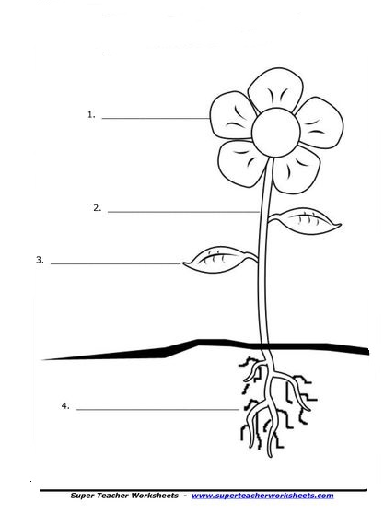
Using the words in the box, label the plant and then describe what each part does by filling in the missing words in the sentences below.
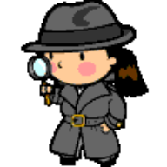
ROOTS LEAVES STEM FLOWER
Important vocabulary

Habitat: A place where an animal lives and gets food, shelter & water
Insects: Have six legs. They have three body parts,
a head, a thorax and an abdomen.
Flora: All plants and fungi in an environment
Fauna: The animals that live in an environment

Important vocabulary

Habitat: A place where an animal lives and gets food, shelter & water
Insects: Have six legs. They have three body parts,
a head, a thorax and an abdomen.
Flora: All plants and fungi in an environment
Fauna: The animals that live in an environment

Flower

Stem
Leaves

Roots

- The FLOWER makes seeds to make new flowers grow. They also attract the pollinators!

- The LEAVES sit in sunshine and help make food for the plant, through a process call photosynthesis.

- The STEM is like a straw. It moves water around the plant. It is long and the flowers and leaves hang from it.

- The ROOTS take in water and food (minerals) from the soil. The also help the flower stand up still.

Important vocabulary and useful ‘Teachers Guides’

Habitat: A place where an animal lives and gets food, shelter & water
Insect: Have six legs. They have three body parts, a head, a thorax and an abdomen.
Minibeast: Invertebrate animal with an exoskeleton
Estimate: Your best guess at an answer.

- A Teachers Guide 3 - A Teacher’s Guide to looking for minibeasts.
- A Teachers Guide 4 - A Teachers Guide to minibeasts.
- A Teachers Guide 7 – A Teachers Guide to pitfall traps.

