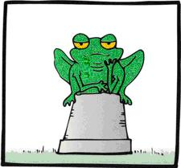
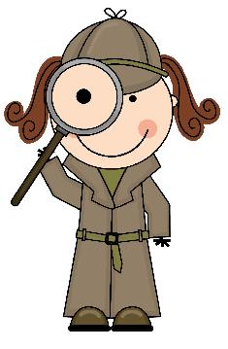
Title: Habitats - missing words
Subject: Science

Using the words in the box below, fill in the missing gaps. Remember to read through all the sentences before you start filling them in.

- A habitat is a place where a PLANT or animal lives.
- Habitats can be large like forests and oceans, or small like ponds or NESTS.
- Habitats provide animals with food, water and SHELTER.

- OCEANS form the world’s largest habitats.

- Animals living in a POND might include frogs, waterboatmen and newts.

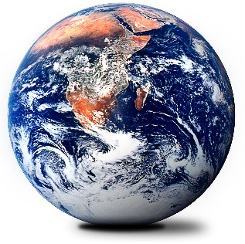
- POLAR regions have short summers and long harsh winters.

- Animals living in a WOODLAND habitat might include owls, deer and foxes.

- DESERTS receive less than 10cm rain a year.

- Animals and plants which live together form a COMMUNITY.

- BIOMES are areas of the globe which have similar climates and plants.
BIOMES COMMUNITY WOODLAND OCEANS POND
POLAR DESERTS SHELTER NESTS PLANT

