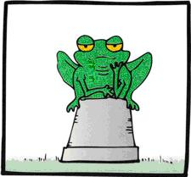

Title: Habitats - missing words
Subject: Science

Date________________________ Name________________________ Location_____________________
Using the words in the box below, fill in the missing gaps. Remember to read through all the sentences before you start filling them in.
- A habitat is a place where a ____________________ or animal lives.
- Habitats can be large like forests and oceans, or small like ponds or ______________.
- Habitats provide animals with food, water and __________________.

- _____________________ form the world’s largest habitats.

- Animals living in a ________________ might include frogs, waterboatmen and newts.

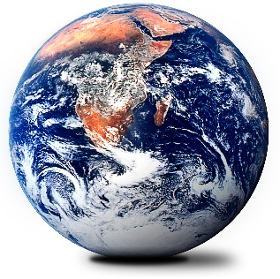
- ______________ regions have short summers and long harsh winters

- Animals living in a ________________ habitat might include owls, deer and foxes

- _________________ receive less than 10cm rain a year

- Animals and plants which live together form a _______________

- _____________________ areas of the globe which have similar climates and plants.
BIOMES COMMUNITY WOODLAND OCEANS POND

POLAR DESERTS SHELTER NESTS PLANT


Important vocabulary and Teacher’s Guides/Further work
Habitat: A place where an animal lives and gets food, shelter & water.
Flora: All plants and fungi in an environment. Fauna: The animals that live in an environment.
A Teachers Guide 4 - A Teachers Guide to minibeasts
Habitat Worksheet 001 - What habitats? Survey worksheet
Habitats worksheet 004 - True or False
Habitats worksheet 006 – Match animals to their habitats
Habitat worksheet 008 – Draw the habitats

